Assignment:
Automation Assignment
Write a Jenkins pipeline to automate the provisioning of an AWS EC2 instance using Terraform and configure the instance using Ansible.
Have different stages of terraform life cycle as your stages and store the state file in remote backend

Steps:
- Create an instance with Jenkins Master
- Write a terraform script to provision the instance
- Push the code to the github
- Install terraform on Jenkins master
- On Jenkins master, write a pipeline script to checkout the code, initialize the terraform, run terraform plan, and terraform apply to creation of the ec2 instance
- Get the IP address of the new instance
- On Jenkins master, install Ansible and create an custom host file and add the IP address to it
- Last step, we need to install any of the services (apache2)

Step1:
- Created an instance with Jenkins
  - https://www.jenkins.io/doc/book/installing/linux/
- 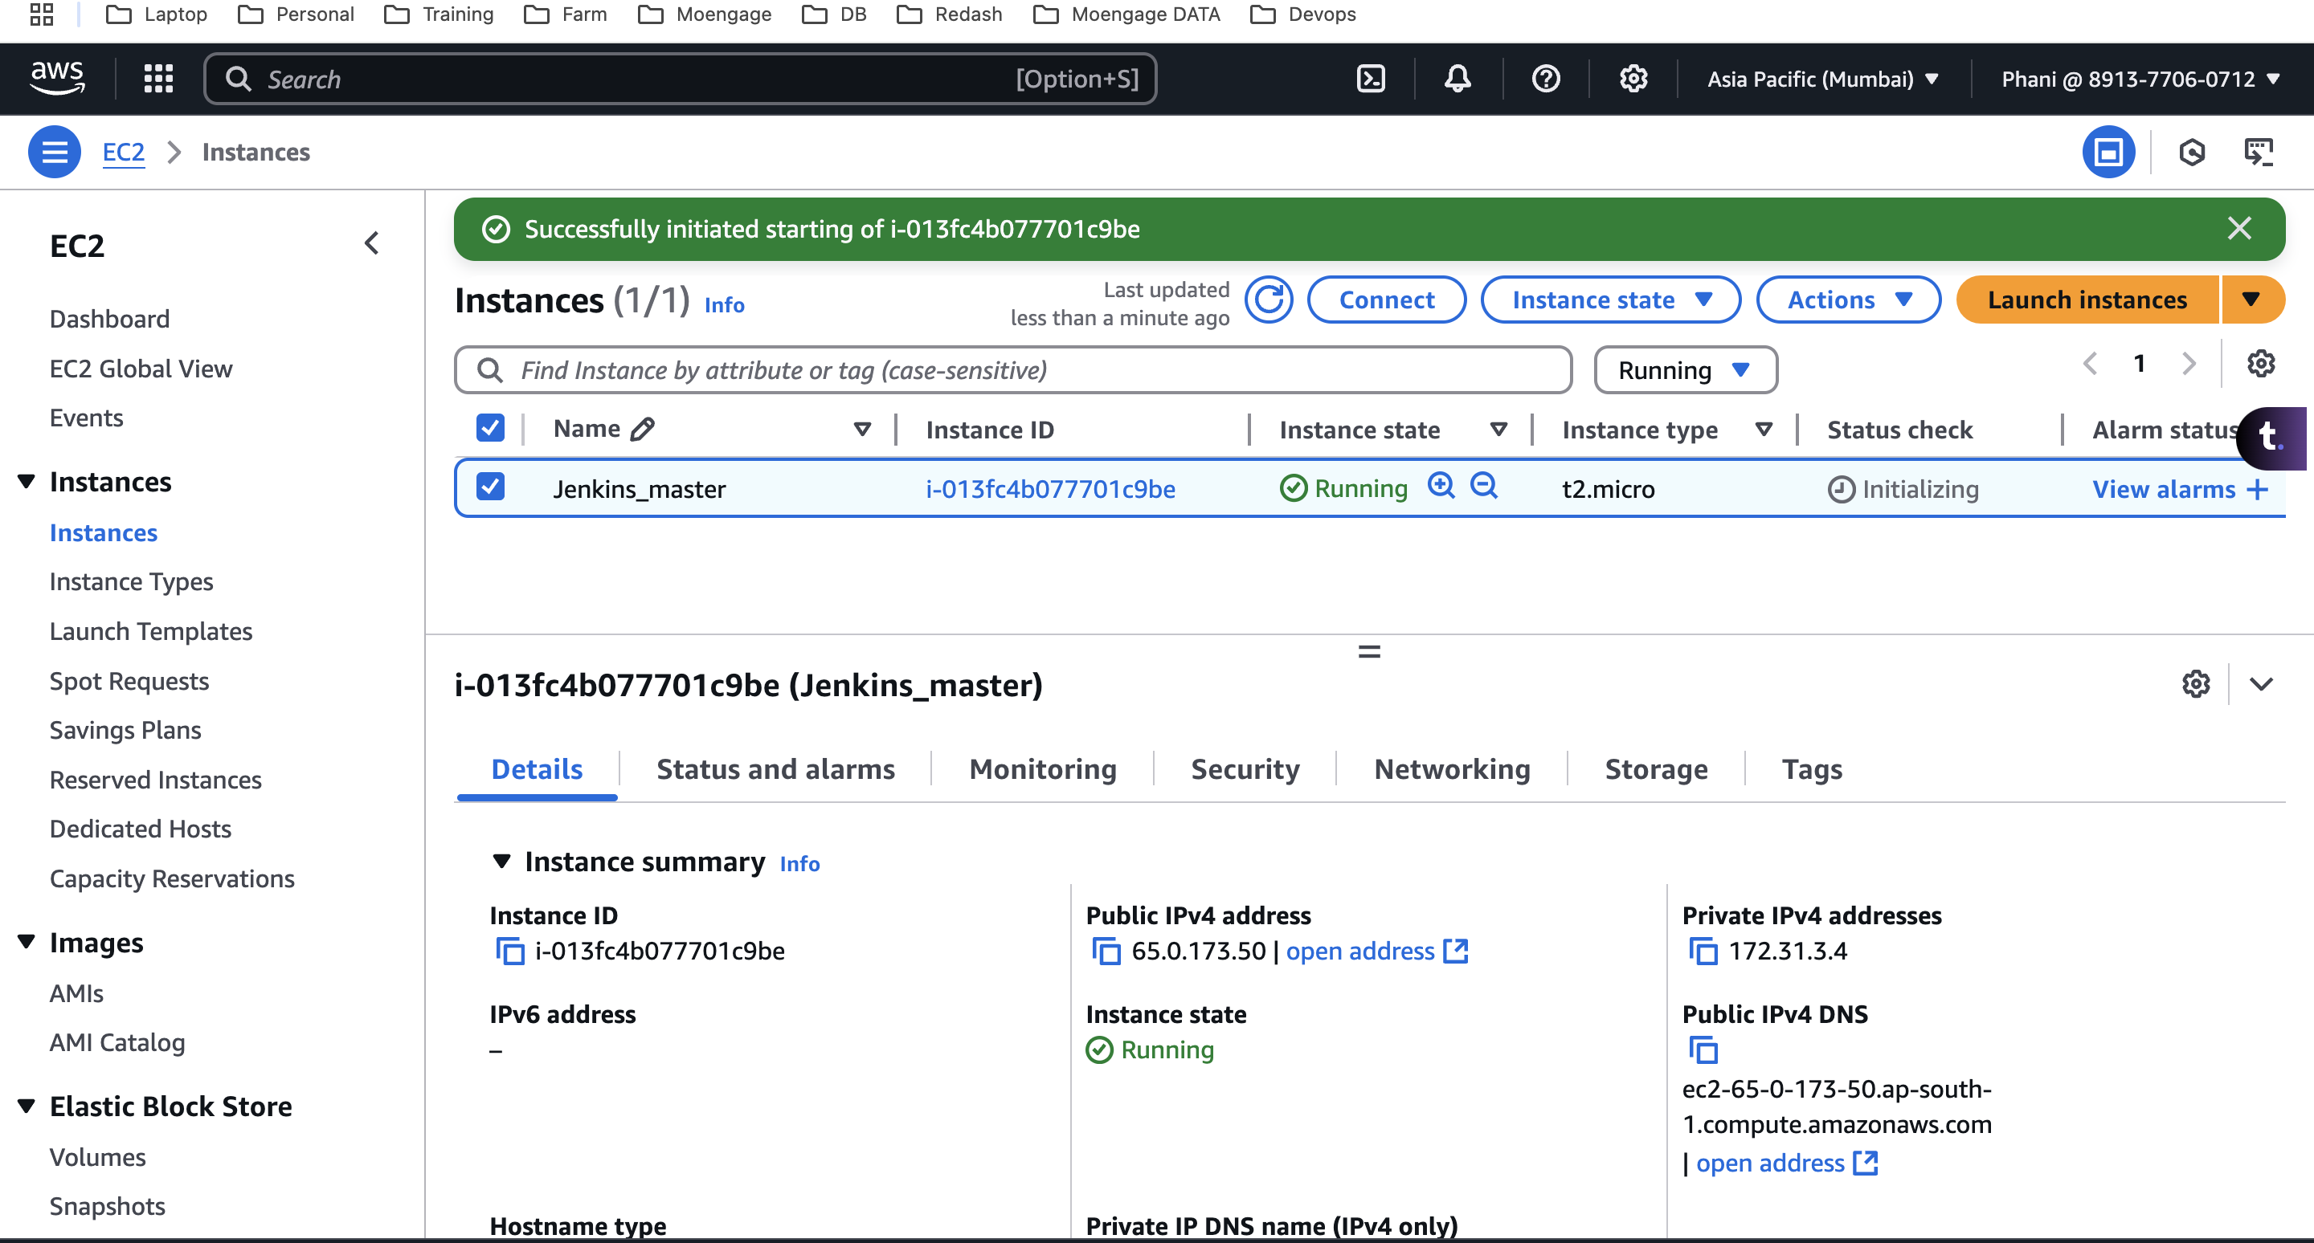

Step 2:
- Write a terraform script to provision the instance using modules
- 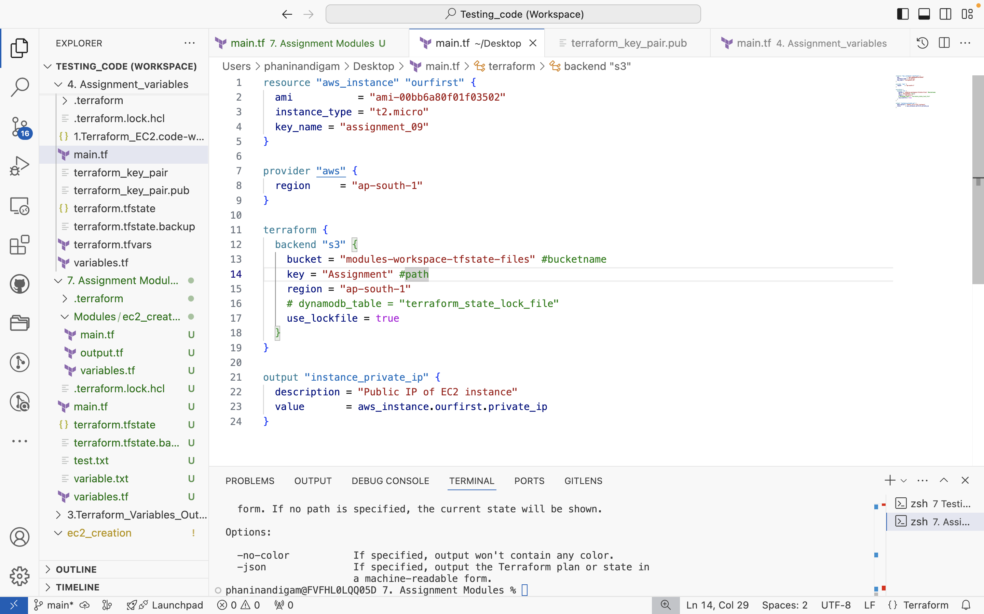

Step 3:
- Push the code to the github
https://github.com/phaninandigam/ec2_creation.git

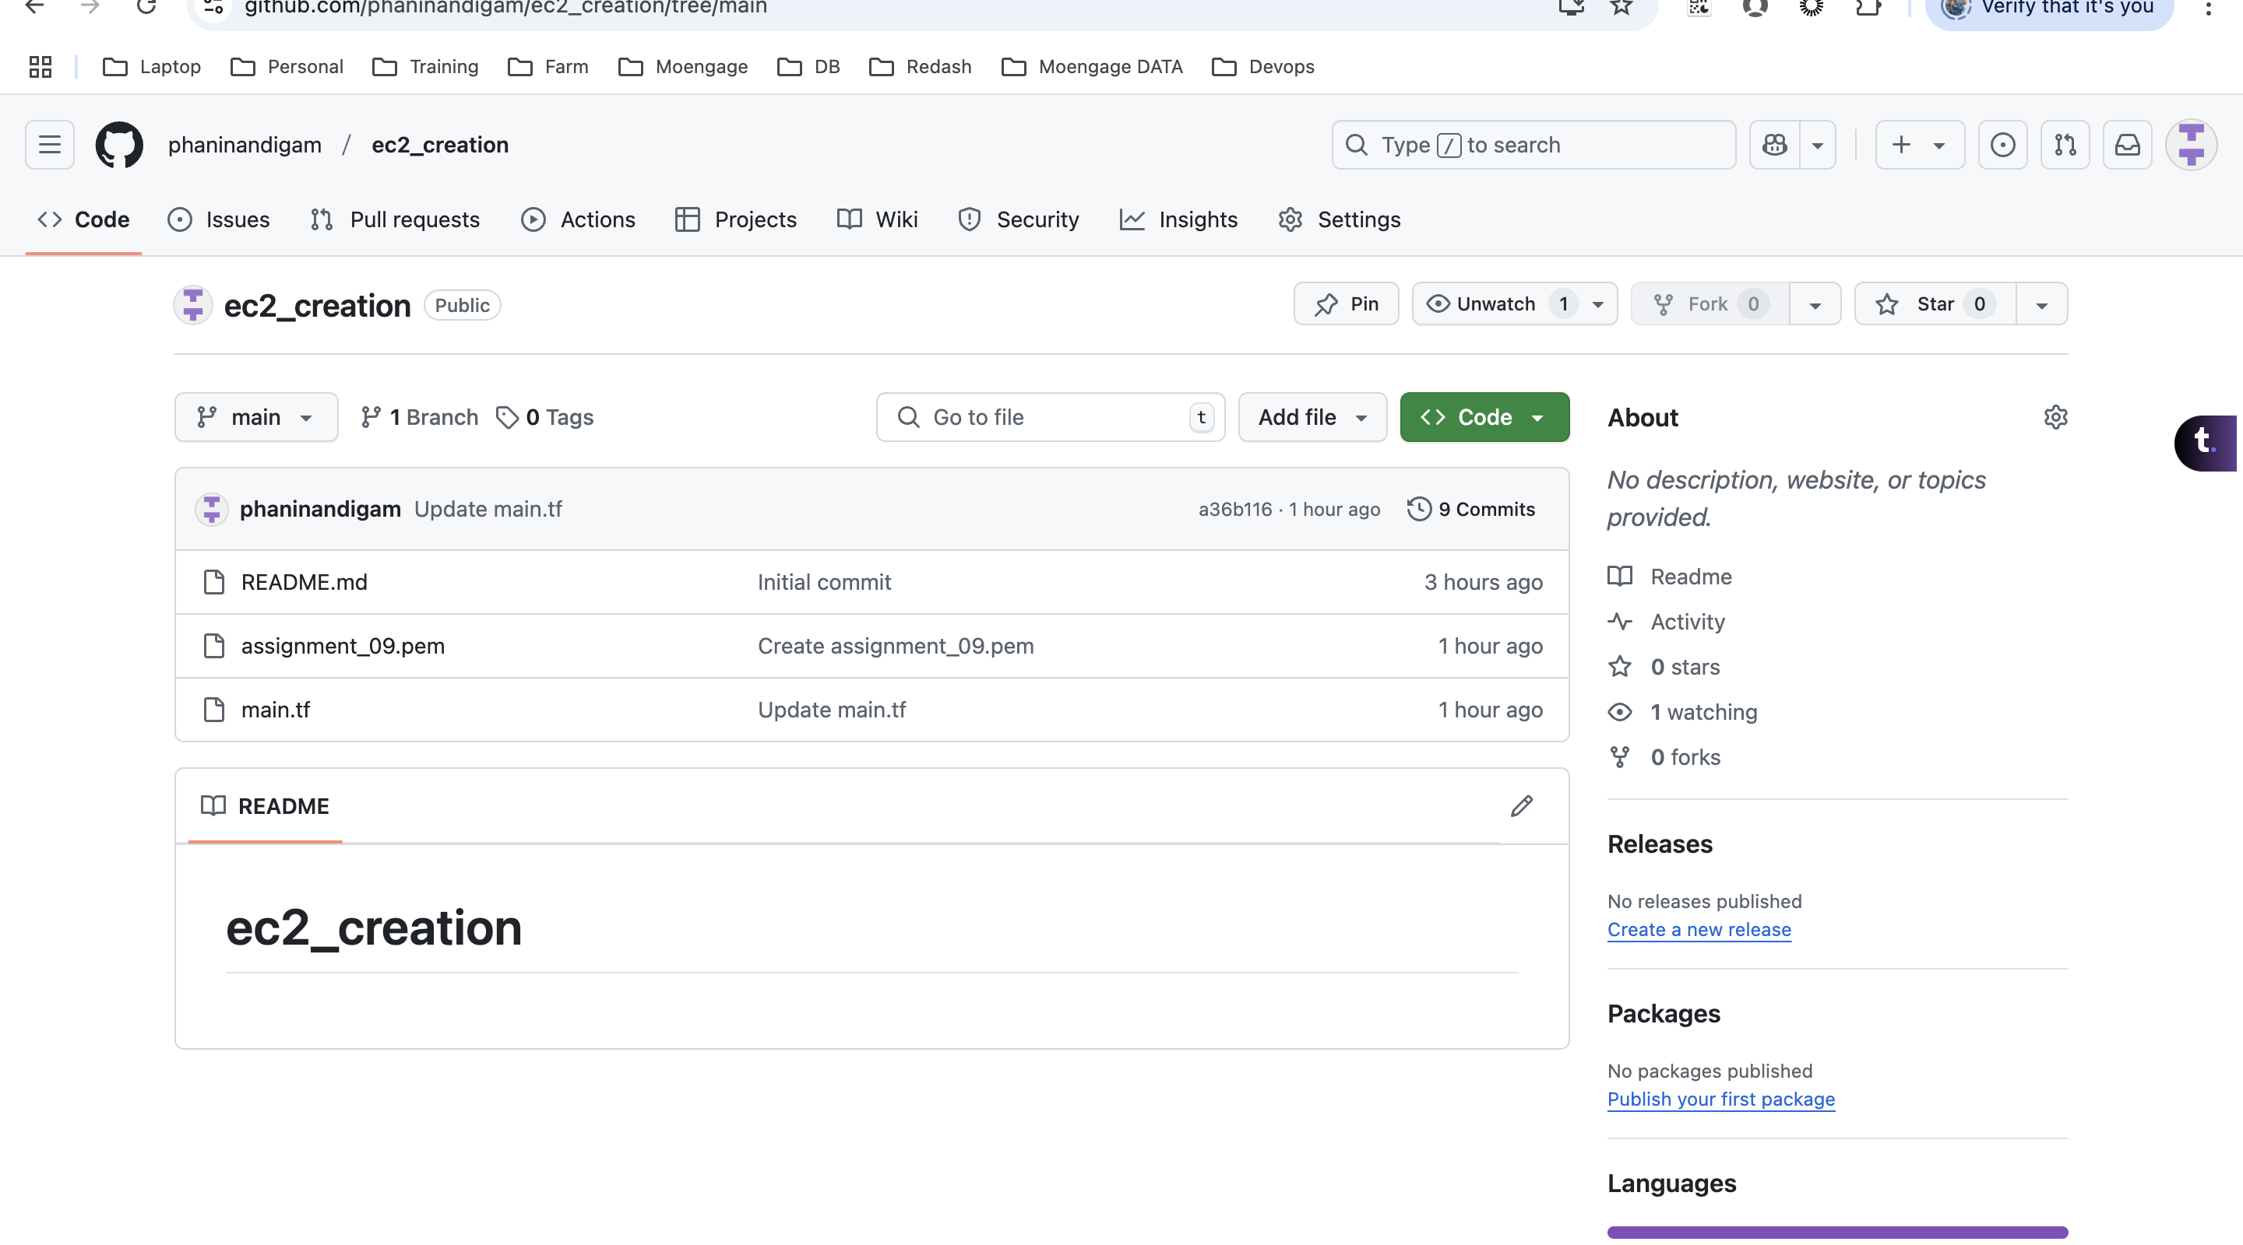
- Here we are storing the pem file, we need this to access the new machine.
- We are using the one which is already present on the console

Step 4:
- Install terraform on master
- https://developer.hashicorp.com/terraform/tutorials/aws-get-started/install-cli

Step5:
- Write pipeline script
- Clone the code
stage("Checkout Code") {
steps{
sh script: '''
rm -rf *
git clone https://github.com/phaninandigam/ec2_creation.git
'''
}
}
- Terraform Intialize
- Before terraform initialize, we need to provide the aws access key and the secret key.
environment {
AWS_ACCESS_KEY_ID = credentials('AWS_ACCESS_KEY_ID')
AWS_SECRET_ACCESS_KEY = credentials('AWS_SECRET_ACCESS_KEY')
AWS_DEFAULT_REGION = "ap-south-1"
}
- We will pass them as the secret text under Jenkins
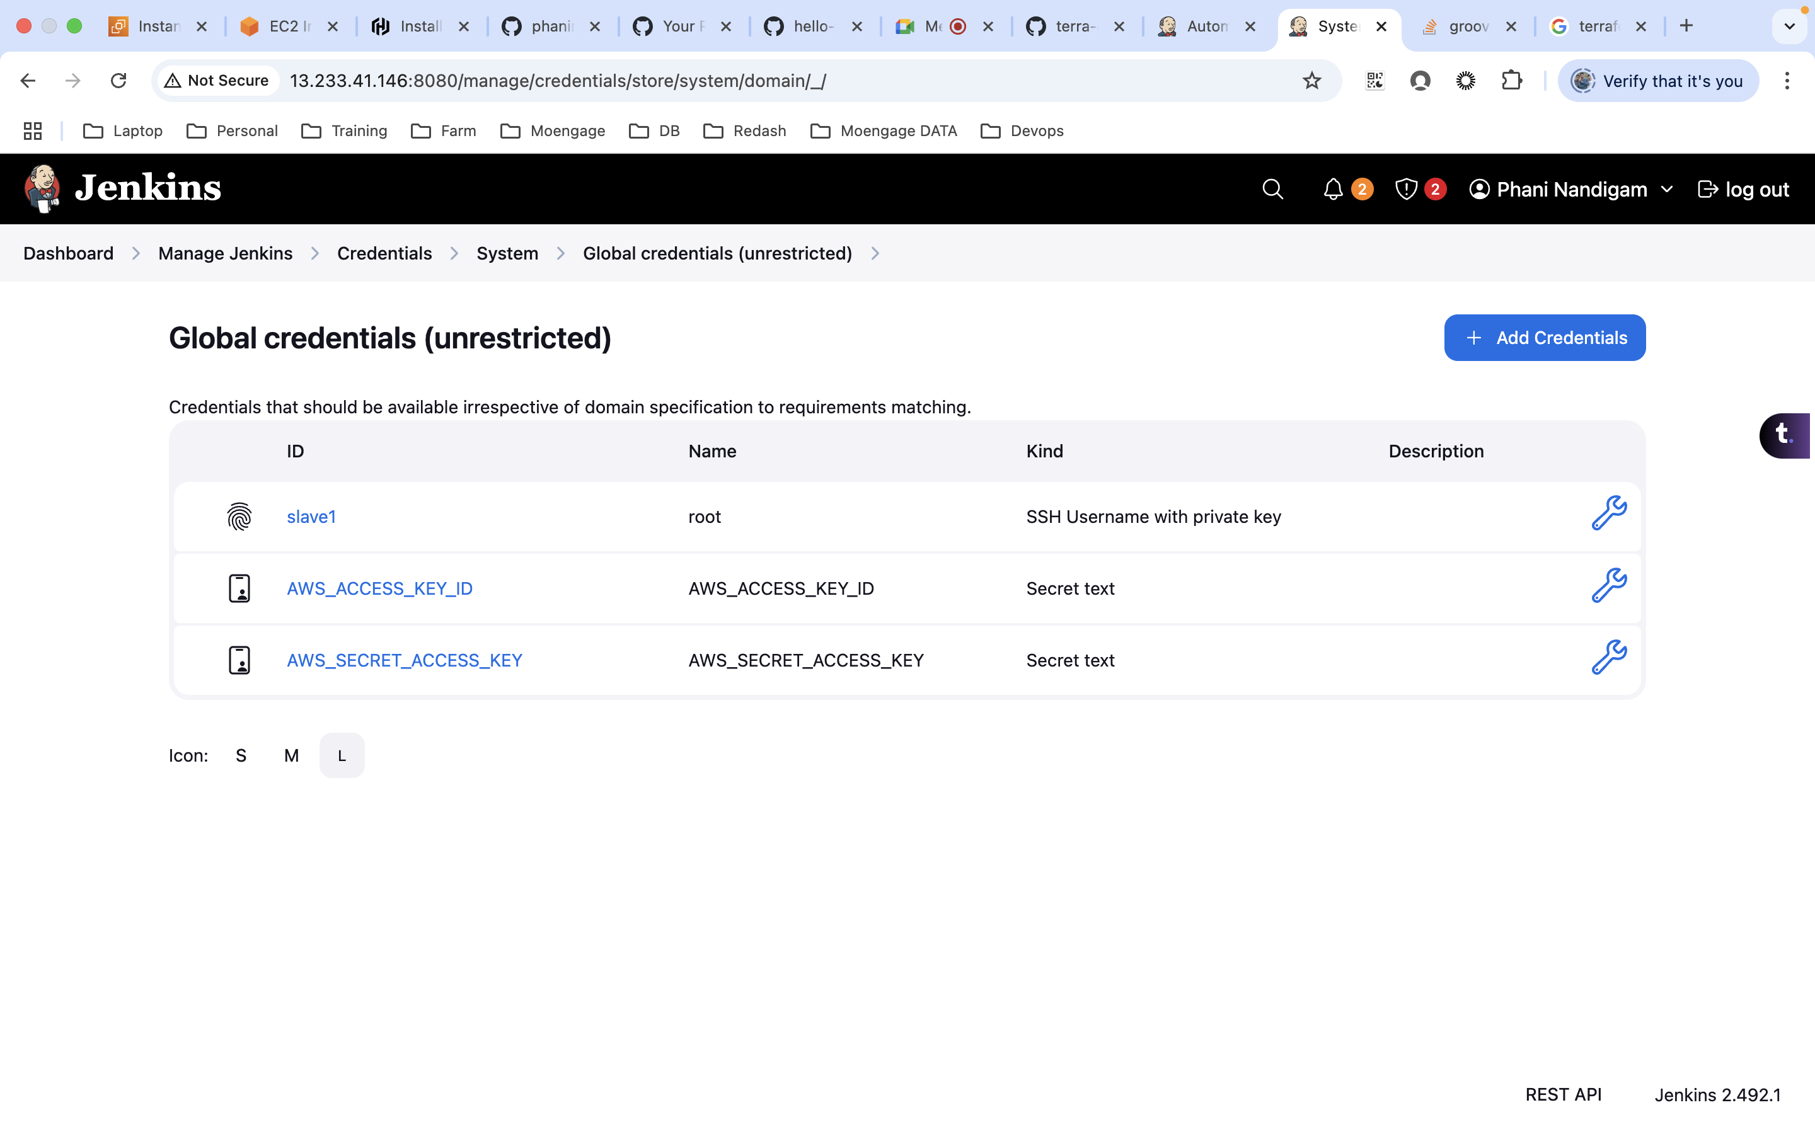
stage("Initilize Terraform"){
steps{
sh script: '''
cd ec2_creation_with_modules
terraform init
'''
}
}

- Terraform plan
stage("Terraform Plan"){
steps{
sh script: '''
cd ec2_creation
terraform plan
'''
}
}

- Terraform Apply
stage("Terraform Apply"){
steps{
sh script: '''
cd ec2_creation
terraform apply -auto-approve
terraform show > tfplan.txt
'''
}
}
- Now, let’s try to get the IP of the newly created ec2 instance and update it in the custom hosts file
stage("IP Update"){
steps{
sh script: '''
cd ec2_creation
val1=$(grep -iw "Private_ip" tfplan.txt |awk -F '"' '{print $(NF-1)}')
echo $val1
mkdir -p ansible
cd ansible
echo $val1>hosts
'''
}
}

- Installing the apach2 service on the new machine.
stage("Ansible - Installation of Apache"){
steps{
sh script: '''
sleep 30
cd ec2_creation
sudo chmod 400 assignment_09.pem
sudo chown jenkins:jenkins assignment_09.pem
cd ansible
git clone https://github.com/phaninandigam/apache2_installion_yaml.git
ansible-playbook -i hosts --private-key ./../assignment_09.pem -u ubuntu apache2_installion_yaml/apache2.yml
'''
}
}

- Terraform Destroy
stage("Terraform Destroy"){
steps{
sh script: '''
sleep 120
cd ec2_creation
terraform destroy -auto-approve
'''
}
}

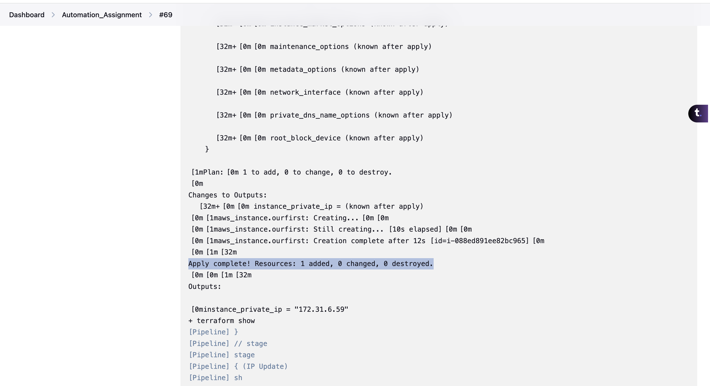
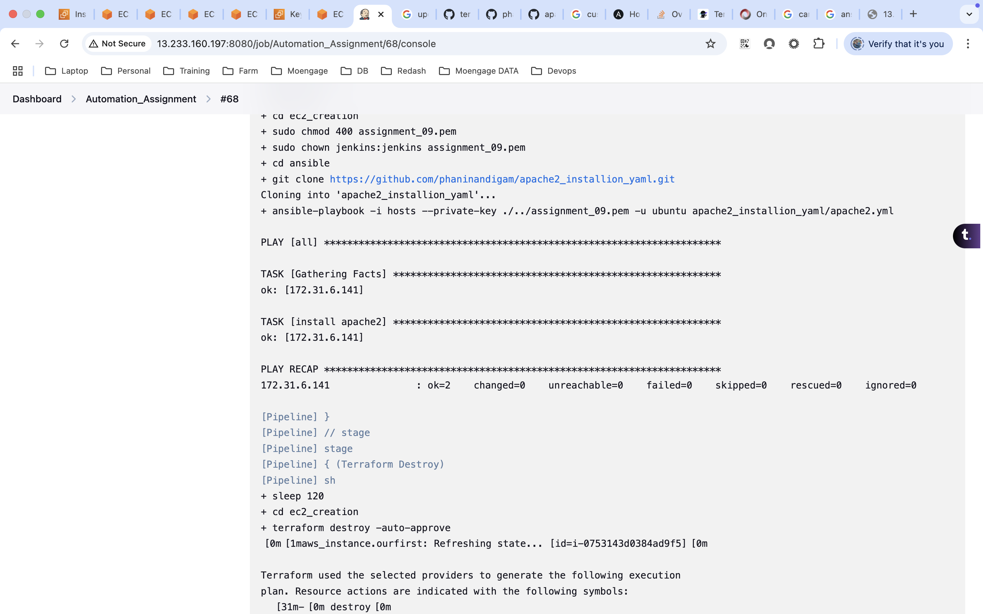

yaml file:
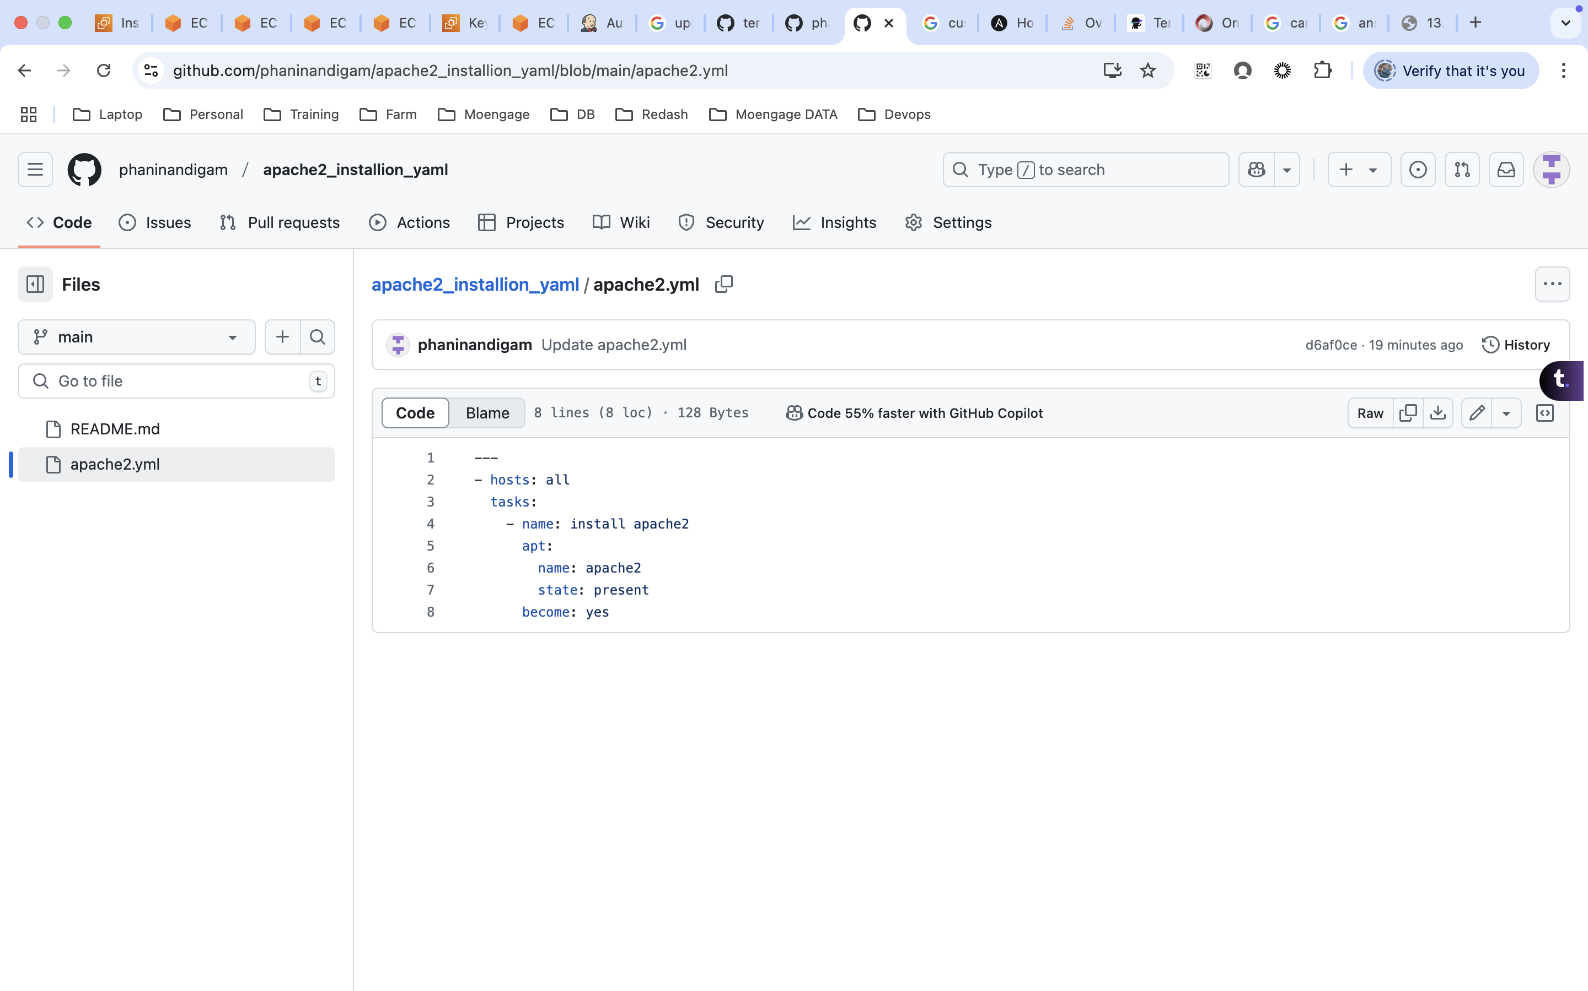
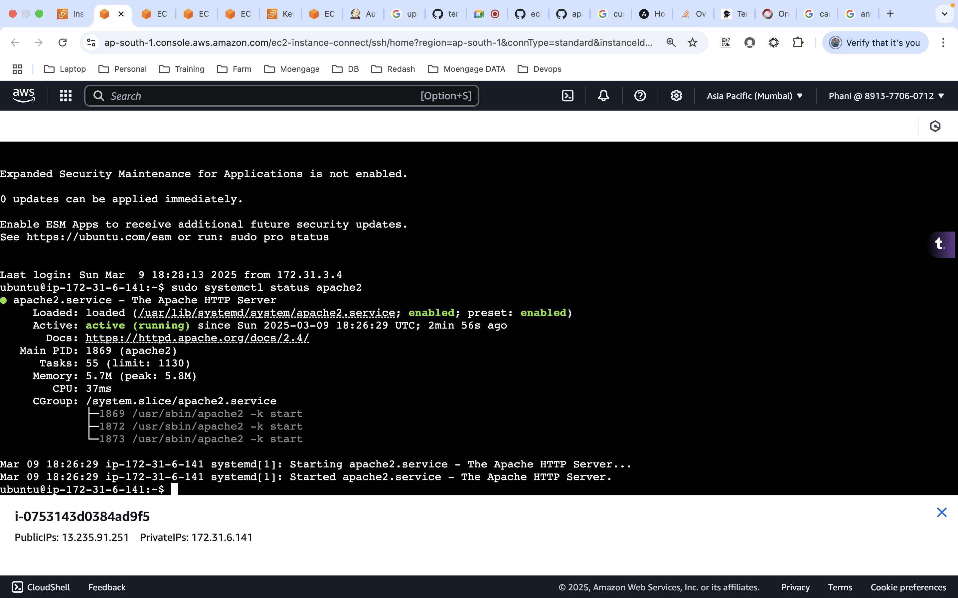

Pipeline:
pipeline {
agent any

environment {
AWS_ACCESS_KEY_ID = credentials('AWS_ACCESS_KEY_ID')
AWS_SECRET_ACCESS_KEY = credentials('AWS_SECRET_ACCESS_KEY')
AWS_DEFAULT_REGION = "ap-south-1"
}

stages {

stage("Checkout Code") {
steps{
sh script: '''
rm -rf *
git clone https://github.com/phaninandigam/ec2_creation.git
'''
}
}

stage("Initilize Terraform"){
steps{
sh script: '''
cd ec2_creation
terraform init
'''
}
}

stage("Terraform Plan"){
steps{
sh script: '''
cd ec2_creation
terraform plan
'''
}
}

stage("Terraform Apply"){
steps{
sh script: '''
cd ec2_creation
terraform apply -auto-approve
terraform show > tfplan.txt
'''
}
}

stage("IP Update"){
steps{
sh script: '''
cd ec2_creation
val1=$(grep -iw "Private_ip" tfplan.txt |awk -F '"' '{print $(NF-1)}')
echo $val1
mkdir -p ansible
cd ansible
echo $val1>hosts
'''
}
}

stage("Ansible - Installation of Apache"){
steps{
sh script: '''
sleep 30
cd ec2_creation
sudo chmod 400 assignment_09.pem
sudo chown jenkins:jenkins assignment_09.pem
cd ansible
git clone https://github.com/phaninandigam/apache2_installion_yaml.git
ansible-playbook -i hosts --private-key ./../assignment_09.pem -u ubuntu apache2_installion_yaml/apache2.yml
'''
}
}

stage("Terraform Destroy"){
steps{
sh script: '''
sleep 120
cd ec2_creation
terraform destroy -auto-approve
'''
}
}
}
}

